**Introduction to Operating Systems**

An Operating System (OS) is a crucial software that acts as an intermediary between computer hardware and the user. It manages hardware resources and provides essential services for the execution of various applications. Here’s a brief overview:

**Types of Operating Systems-**

• Batch Operating Systems: Execute jobs in batches without user interaction.

• Time-Sharing Operating Systems: Allow multiple users to interact with the system simultaneously.

• Distributed Operating Systems: Manage a group of independent computers and make them appear as a single system.

• Real-Time Operating Systems (RTOS): Designed for systems that require real-time processing.

• Embedded Operating Systems: Specialized OS designed for embedded systems with limited resources.

**Examples of Operating Systems:**

• Windows

• Linux

• macOS

• Android

• iOS

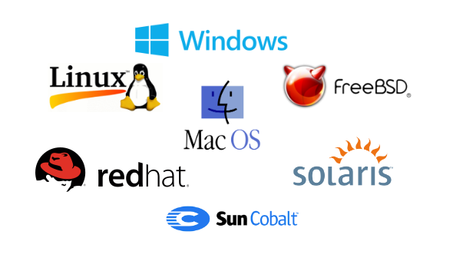

**Services of Operating Systems**-

* Process Management: Manages the execution of processes, including scheduling, creation, and termination.
* Memory Management: Allocates and deallocates memory space for processes, ensuring efficient memory usage.
* File System Management: Handles the creation, deletion, reading, and writing of files and directories.
* Device Management: Manages hardware devices, facilitating communication between the OS and peripheral devices.
* Security and Access Control: Protects system resources through user authentication and access permissions.
* User Interface: Provides an interface (CLI or GUI) for users to interact with the system.
* Error Detection and Handling: Detects errors in hardware and software, ensuring system stability.

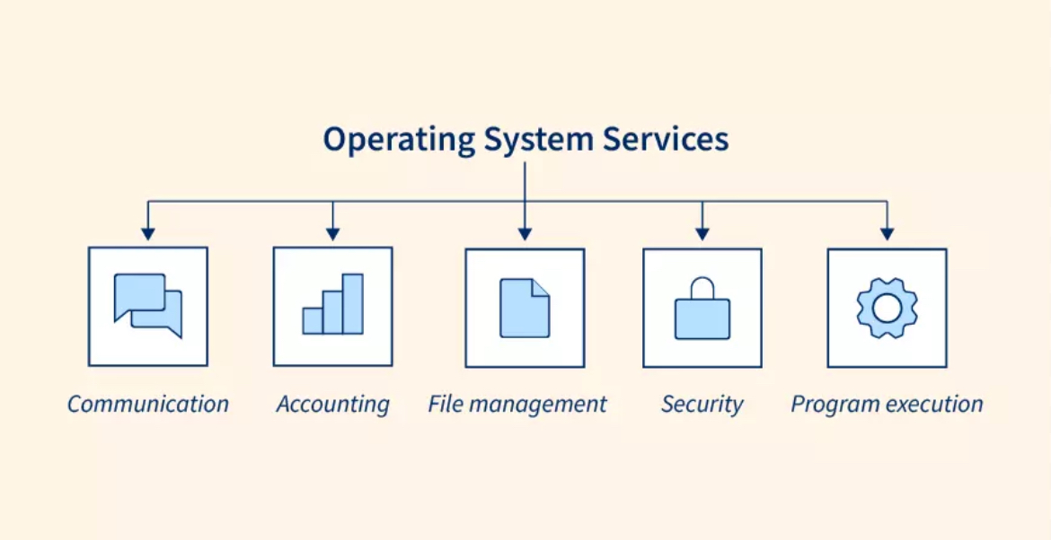

**Need for Operating Systems**

Operating Systems are essential because they manage hardware resources, provide a user interface, enable application execution, and ensure system security and stability, making it possible for users and software to interact with the computer efficiently.

**LINUX OS:**

Developed by Linus Torvalds in 1991, the Linux operating system is a powerful and flexible open-source software platform. It acts as the basis for a variety of devices, such embedded systems, cell phones, servers, and personal computers.

Linux, that's well-known for its reliability, safety, and flexibility, allows users to customize and improve their environment to suit specific needs. With an extensive and active community supporting it, Linux is an appealing choice for people as well as companies due to its wealth of resources and constant developments.

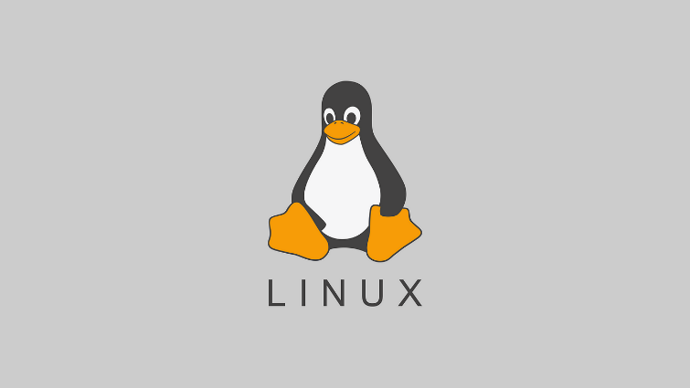

**History of linux:**

A popular open-source operating system is Linux. It was initially created by Linus Torvalds in 1991. At the time, Torvalds was a computer science student at the University of Helsinki, Finland and began working on the Linux project as a personal endeavour.

Early versions of Linux were primarily used by technology enthusiasts and software developers, but over time it has grown in popularity and is used in various types of devices such as servers, smartphones, and embedded systems. Linux is considered one of the most stable, secure and reliable

operating systems and is widely used in servers, supercomputers and enterprise environments.

Today, Linux is one of the most widely used operating systems in the world, with an estimated 2.76% of all desktop computers and more than 90% of the world's top supercomputers running on Linux, and approx. 71.85% of all mobile devices run on Android, which is, you guessed it, Linux-based. The Linux community has expanded to include thousands of developers and users who work on the creation and upkeep of the operating system.

Nowadays Linux has many distributions (versions) namely:

* Ubuntu
* Fedora
* Arch
* Plasma
* KDE
* Mint
* Manjaro

**Linux Distributions**

Linux distributions (distros) are different versions of the Linux operating system, each tailored for specific needs. They combine the Linux kernel with a package management system, software, and utilities. Here are a few popular distributions:

1. Ubuntu: User-friendly, popular for desktops and beginners, with strong community support.

2. Fedora: Cutting-edge features, backed by Red Hat, often used by developers.

3. Debian: Known for stability and extensive software repositories, often used on servers.

4. CentOS: A free, community-supported version of Red Hat Enterprise Linux, popular in enterprise environments.

5. Arch Linux: Lightweight and highly customizable, aimed at advanced users.

6. Mint: Based on Ubuntu, it's designed to be easy for newcomers, with a familiar interface.

**Applications of linux**

1. Mozilla Firefox

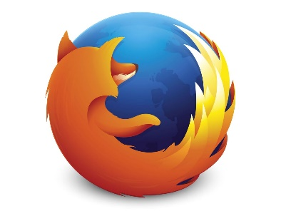

Firefox is the default browser for various Linux distributions such as Linux Mint and Ubuntu. It is the fastest web browsing software for Linux with an incredibly user-friendly interface. As a Linux application, Its auto-update feature makes it a very convenient application.

2. Thunderbird



Thunderbird is a free and powerful yet easy-to-use email client which helps to manage your emails with ease. The wizard acts as an assistant that gives a walkthrough of this application of Linux. An unlimited number of accounts can be added and managed by this amazing software. This Linux application provides a better way to sort the mail folders.

3. LibreOffice

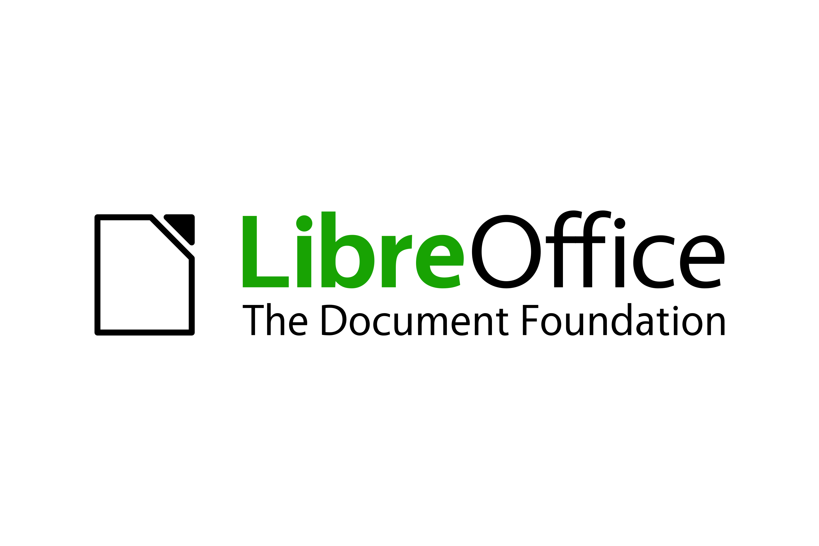

LibreOffice is free, complete, and one of the best office suites. It has a basic interface along with extraordinarily advanced features. These applications of Linux are pre-installed in Ubuntu and its derivatives. The documents can be saved in various formats such as DOC, DOCX, PPT, PPTX, XLSX, etc.

4. VLC Media Player



VLC is the most famous media player which supports any kind of audio or video files without the need to download additional codecs. It can also be used for clipping videos and helps in converting files from one format to the other such as flv to mp4.

5. Shortcut

Shortcut is an open-source and free video editing software available for Linux, macos as well as windows. It supports all kinds of audio and video formats including the latest 4K view

6. GIMP

GIMP is a free image editor that allows you to edit and retouch images by resizing, adding layers, noise reduction, cropping, and color adjustments. Photoshop plugins can also be added to GIMP.



7. Audacity

Audacity is an open-source digital audio editor and recording application that supports Windows, macOS, and Linux. It supports recording from multiple inputs such as a keyboard and a USB microphone simultaneously.



8. Visual Studio Code

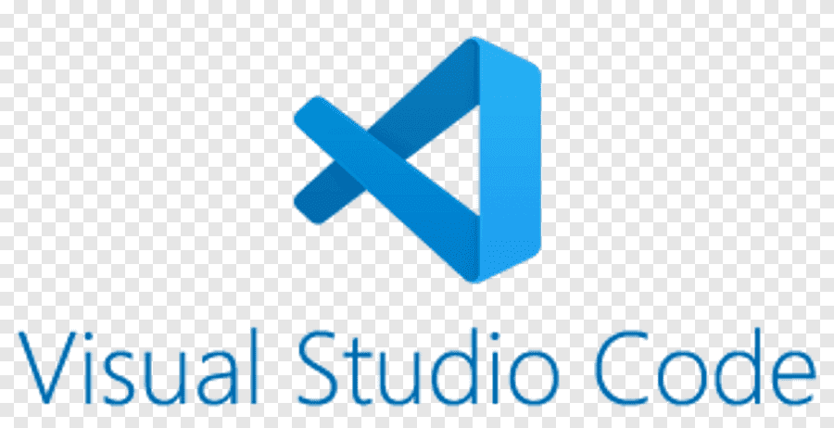

Visual Studio Code is a free text editor provided by Microsoft for coding and programming. It is compatible with Linux, Windows, and macOS. This Linux application supports various plugins such as code refactoring, debugging, keyboard shortcuts, and default integration with Git.

9. VirtualBox

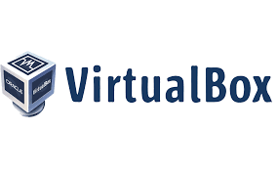

VirtualBox is a free and open-solsce virtualization machine owned by Oracle. It is a cross-platform software, allowing multiple operating systems to be run on a single computer. This Linux application is used for the simulation of various machines on a single device.

10. ClamAV

ClamAV is free and cross-platform anti-virus software for detecting various malicious viruses and removing them from servers and computers. This software is generally used on the server side as an email virus scanner.

